**IT24104275 – Weerarathna P.G.D.D.**

**PS – IT2120**

**Lab Sheet – 07**

1. A train arrives at a station uniformly between 8:00 a.m. and 8:40 a.m. Let the

random variable X represent the number of minutes the train arrives after 8:00

a.m. What is the probability that the train arrives between 8:10 a.m. and 8:25

a.m.?

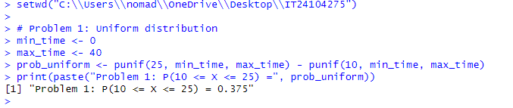

2. The time (in hours) to complete a software update is exponentially distributed

with rate λ =1/3. Find the probability that an update will take at most 2 hours.

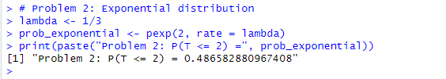

3. Suppose IQ scores are normally distributed with a mean of 100 and a standard

deviation of 15.



1. 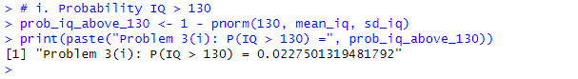What is the probability that a randomly selected person has an IQ above 130?
2. What IQ score represents the 95th percentile?

